Q1: For the N.N shown below, find the outputs applying

sigmoid A.F ,Knowing that x= [1 1]

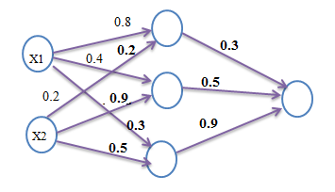

Q2: Implement the followings by N.N, using threshold A.F for all.

EX- OR

Note: implement EX-OR by using only NAND gates.